**GitHub repo**: <https://github.com/barbara-mooney/servicenow-app>

**Description**: a simple app that utilizes ServiceNow API to pull data from the user’s account and shows their list of open incidents; user can also click on each item to see further details. The goal was accomplished, but more functionality could be added, such as filtering options, edit button, add comments, etc.

Displays list of incidents

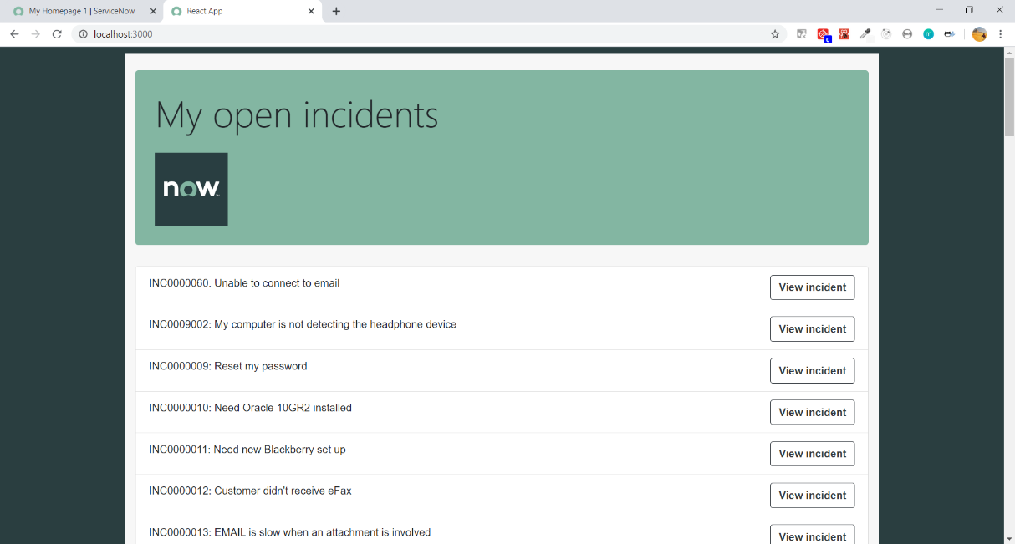

Display info details of incident

